1. Design DFA using simulator to accept even number of a’s.

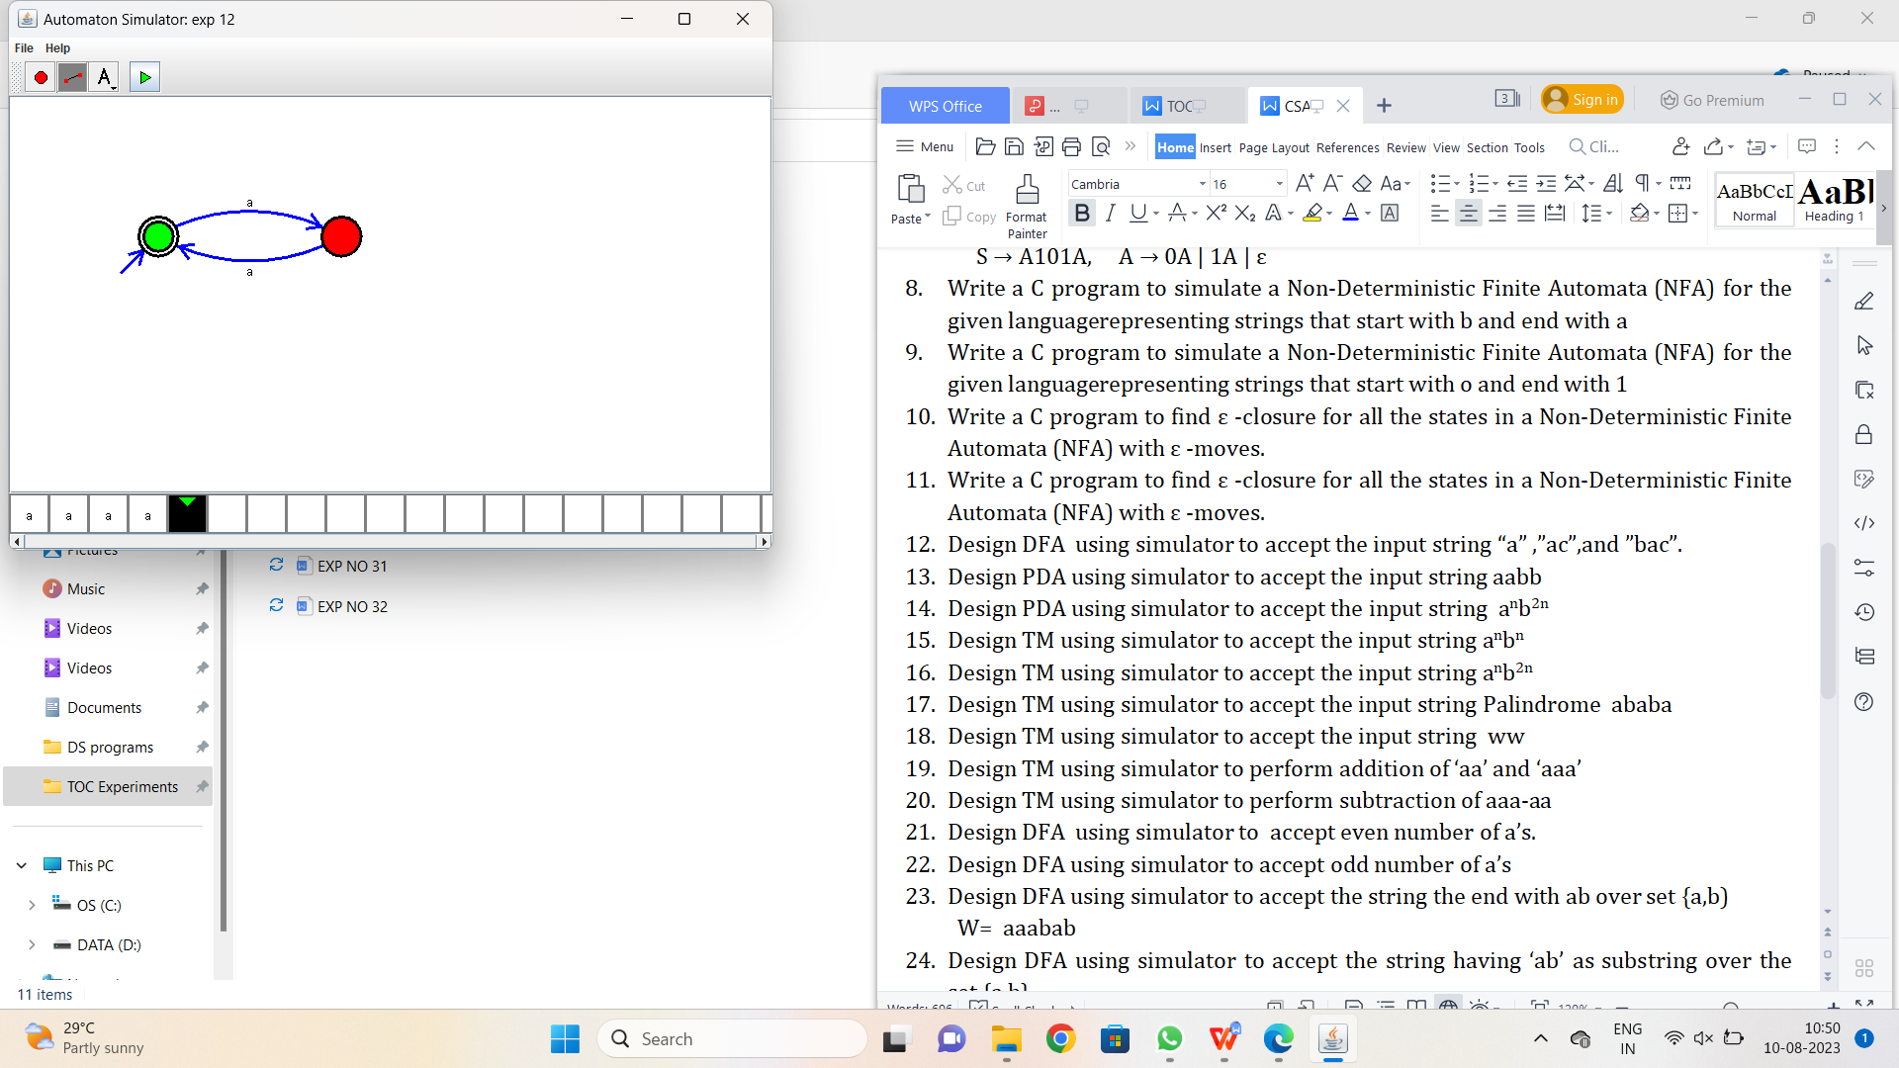

Result:-

From the above DFA diagram valid the given condition.